Technical Recommendation
Model：BRTIRUS2110A
Name：20Kg Six axis robot
Robot version :11 version
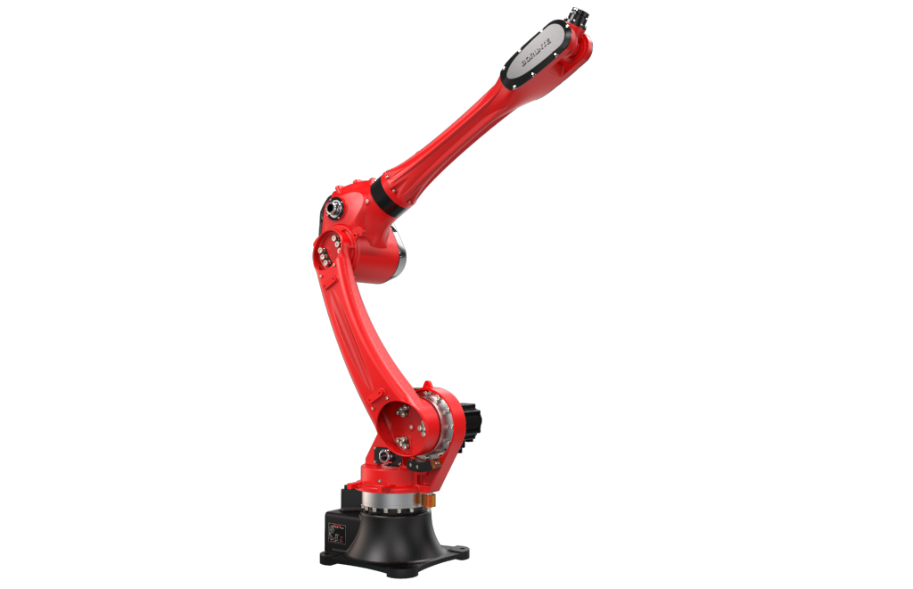

（Without further notice if specification and exterior have been changed because of improvement. Thanks for your understanding.）”

1. BRTIRUS2110A robot profile

1.1.Introduction of BRTIRUS2110A

BRTIRUS2110A is a six axis robot developed by BORUNTE for complex applications with multiple degrees of freedom. It has a 2100mm long arm span and a maximum load of 10kg. With six degrees of flexibility, it can handle scenarios such as welding, loading and unloading, and assembling.
High IP code：Wrist: IP54 Body: IP50 Dust-proof and water-proof
High accuracy：repeated positioning accuracy: ±0.05mm

1.2.Features of BRTIRUS2110A

- Strong reliability - sturdy and durable, with minimal use of components, strong reliability, and long maintenance intervals;
- Fast speed - optimizes the acceleration and deceleration performance of the robot, minimizing its working cycle time;
- High precision - stable production quality of parts, with optimal trajectory accuracy and repeated positioning accuracy;
- Durable and sturdy - suitable for harsh production environments;
- Universality - Good universality, can be used for various tasks. For example, replacing the end effectors (claws, tools, etc.) of robot can perform different tasks;
- Programmable - It can be reprogrammed according to the changing needs of their working environment, so they can play a good role in the flexible manufacturing process of small batch varieties.

1.3. Application cases of BRTIRUS2110A
(1). Handling (2). Stamping (3). Injection molding (4). Grinding (5). Cutting (6). Deburring (7). Gluing (8). Stacking (9). Spraying, etc.

2. BRTIRUS2110A Functions and feature description

2.1.General layout of BRTIRUS2110A

BRTIRUS2110A adopts a six axis joint robot structure, and six servo motors drive the rotation of the six joint axes through a reducer. It has six degrees of freedom, namely rotation (X), lower arm (Y), upper arm (Z), wrist rotation (U), wrist swing (V), and wrist rotation (W).

2.2. BRTIRUS2110A features

- Adopting a servo motor with RV reducer structure, it has strong load-bearing capacity, wide working range, fast speed, and high accuracy;
- Control system handheld conversational teaching pendant is simple and easy to learn, very suitable for production.
3. The robot body adopts partial internal wiring, which is safe and environmentally friendly.

2.3. Working conditions of BRTIRUS2110A
1. Power supply: 220V±10% 50HZ±1%
2. Operating temperature: 0℃ ~ 40℃
3. Optimal environmental temperature: 15℃ ~ 25℃
4. Relative humidity: 20-80% RH (No condensation)
5. Mpa: 0.5-0.7Mpa

3.BRTIRUS2110A robot specifications
Model |  |  | BRTIRUS2110A
Axes |  |  | 6 axis
Loading ability |  |  | 10KG
IP code |  |  | IP56 Dust-prof and water-proof
Repeated positioning accuracy |  |  | ±0.05MM
Maximum arm span |  |  | 2100MM
Weight |  |  | 230KG
Max speed | J1 |  | 110°/s |  |  |  | J2 |  |  |  | 146°/s
Max speed | J3 |  | 134°/s |  |  |  | J4 |  |  |  | 273°/s
Max speed | J5 |  | 300°/s |  |  |  | J6 |  |  |  | 336°/s
Motion range | J1 |  | ±155° |  |  |  | J2 |  |  |  | -90°（-140° Lower probe adjustable）/+65°
Motion range | J3 |  | -75°/+110° |  |  |  | J4 |  |  |  | ±180°
Motion range | J5 |  | ±115° |  |  |  | J6 |  |  |  | ±360°
Allowable torque | J4 |  | 52N*M |  |  | J5 |  | 33.6N*M |  |  |  | J6 |  |  |  | 16.8N*M
Allowable moment of inertia | J4 |  | 0.664KG*M2 |  |  | J5 |  | 1.12KG*M2 |  |  |  | J6 |  |  |  | 0.155KG*M2
Mounting environment | Operating temperature： 0℃~40℃ Best temperature：15℃~25℃ Relative humidity：20~80%RH（No condensation）
Mpa | 0.5~0.7Mpa
Power supply | 220V±10％ 50HZ±1％
Core component | Name |  | Operating system |  |  |  |  |  |  | Brand |  |  |  |  | BORUNTE
Core component |  |  | Casting body |  |  |  |  |  |  |  |  |  |  |  | BORUNTE
Core component |  |  | Servo motor |  |  |  |  |  |  |  |  |  |  |  | BORUNTE
Core component |  |  | Reducer |  |  |  |  |  |  |  |  |  |  |  | BORUNTE
Core component |  |  | Electrical component |  |  |  |  |  |  |  |  |  |  |  | BORUNTE
Oil content | J1 | 1695ml | J2 | 820ml | J3 |  | 712ml |  | J4 | 325ml |  |  | J5 | 20ml |  |  | J6 | 35ml
Vulnerable parts | Timing belt |  | Tooth shape 3M, 100 teeth, 6mm wide, reinforced
Vulnerable parts | Timing belt |  | Tooth shape 3M, 145 teeth, 6mm wide, reinforced
Robot accompanying materials |  |  | USB

The rated power, specifications, external dimensions, etc. of this product are subject to modification without prior notice.

Technical data and illustrations are for supply reference only and reserve the right to make changes.



